Math Projects for 4/20-4/24: Answer the questions on another piece of paper. Send a picture me by email or text.

- Which flat shape is part of each 3-D shape? None

a. cylinder 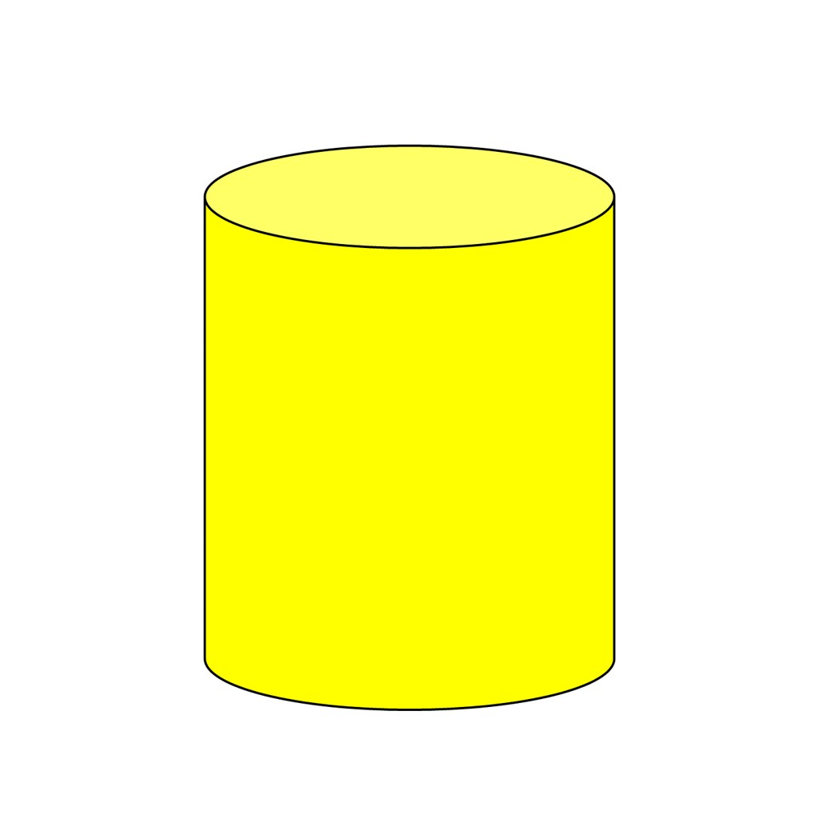 b. cube 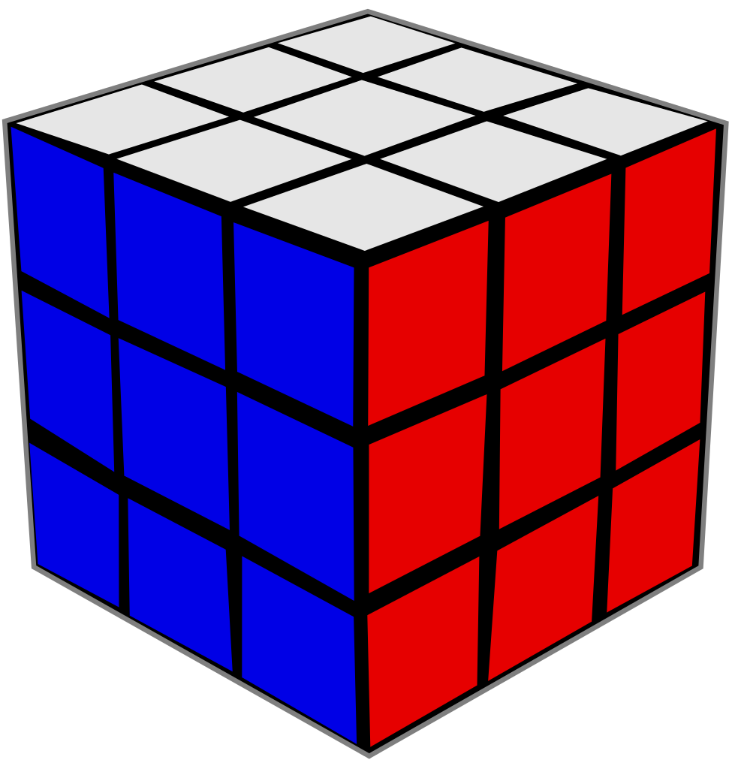 c cone. d. sphere 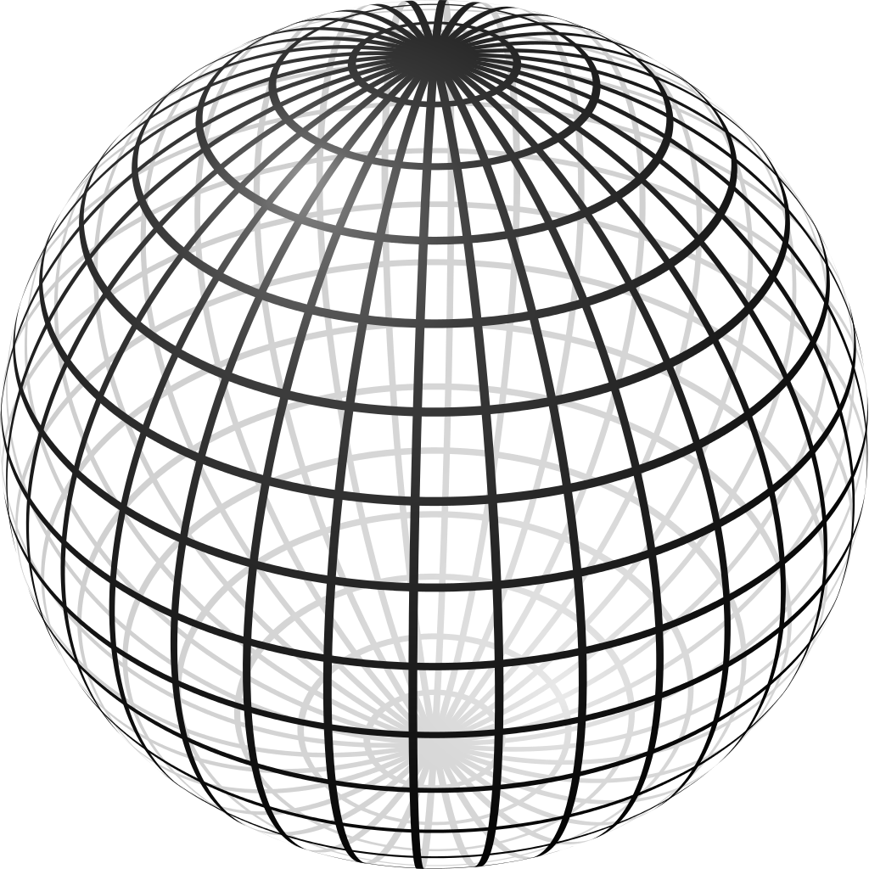

2.

a. Put a V behind the cone.
b. Put a W in front of the cone.
c. Put an X below the sphere.
d. Put a Y above the cube.
e. Put a Z next to the cylinder.

- Draw 20 rectangles and 18 circles.

- How many sides do the following shapes have?

Hexagon ______ Square ______ Triangle ______

- Count to 100. What comes after 19? What comes after 31? What comes after 45?

- Fill in the blanks using the pictures:

______ +______=______ _______+_______=______ _______+_______=_______

Language Arts projects for 4/20-4/24

- Sing the ABC song and write the alphabet every day.

- Draw 5 words that start or end with each of the following letters: W, X, Y, and Z. Practice the sounds they make.

- What is your favorite holiday? What do you do on then? Why do you like it?

- Read at least 3 stories using raz-kids or any other stories if you can't get online. Please make sure your student is only reading stories for their raz-kid account. I do keep track of how much they read.

- Draw a picture to go with the memory verse.

