Math Projects for 5/18-5/20: We have finished the kindergarten curriculum and this week we will be doing some 1st grade curriculum to get the students ready for next year. Answer the questions on another piece of paper. Send a picture me by email or text.

- Count the squares and write the numbers.
_______ a.

_______ b.

_______ c.

_______ d.

_______ e.

_______ f.
- What hour is the arrow pointing to on the clock?
a.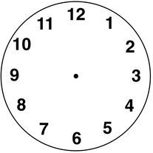 b. c. d.
______ o’clock ______ o’clock ______ o’clock ______ o’clock
Language Arts projects for 5/18-5/20
1. Get ready to share a hero report on Wednesday with the class.
a. Who is your hero? ___________________________________________
b. Where does your hero live? ______________________________________
c. What does my hero do that is special? __________________________________________
d. Why is he or she your hero? ___________________________________________________
- Make an ABC book. In the boxes write the letters N-Z (one letter in each box) and write or draw something that starts with that letter.

N n O o P p Q q

R r S s T t U u

V v W w X x Y y

Z z

