Science project instructions for 5/4-5/8: Read the directions on the science page to test how greasy different food is. Take a picture of the page and email or text it to me.
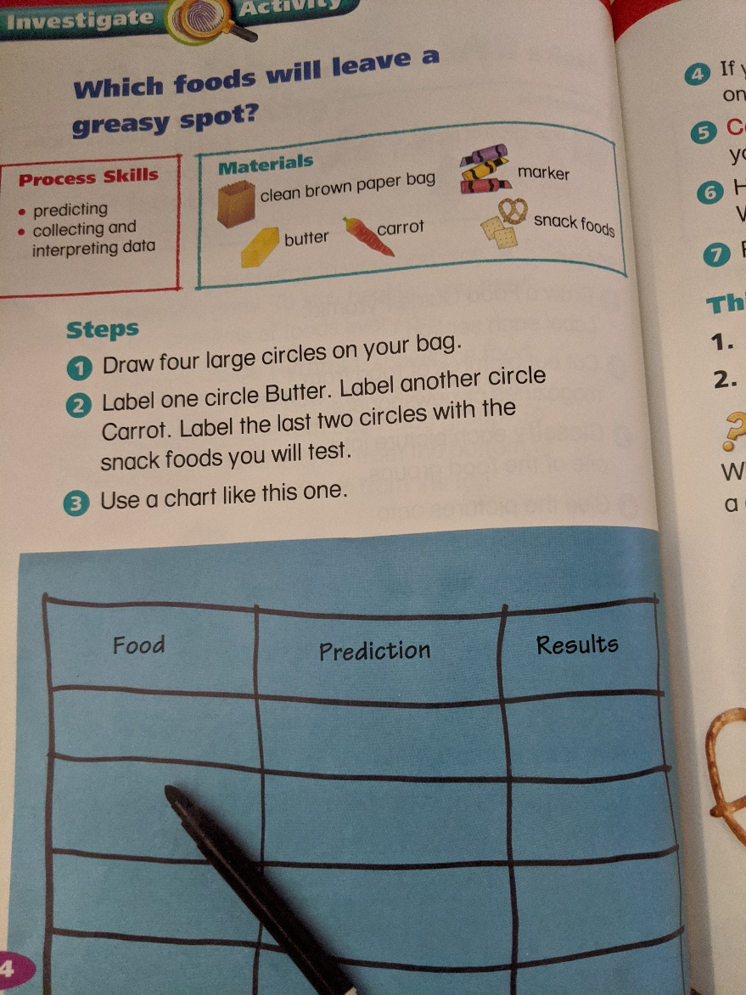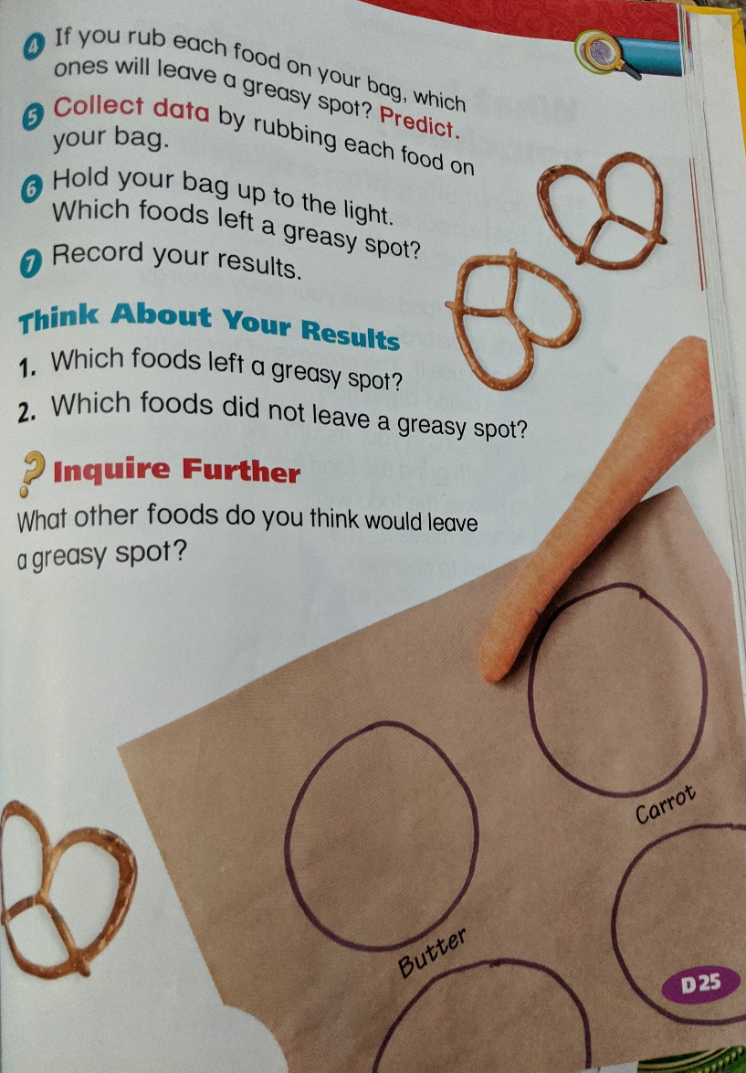
Food | Prediction | Result

Which food do you think is healthiest?

Social Studies project instructions for 5/4-5/8: Read the social studies pages and answer the questions at the end. Take a picture of the page and email or text it to me.
