Math Projects for 5/4-5/8: We have finished second grade curriculum and this week we are starting an introduction to 3rd grade curriculum. Answer the questions on another piece of paper. Send a picture me by email or text.
- Round each number to the nearest tens to estimate the addition and subtraction questions. 24 (rounds to 20) + 38 (rounds to 40) 20 + 40 = 60
79 (rounds to 80) -56 rounds to 60) 80-60=20
  - 18+29= c. 13+28= e. 31+22=
  - 42-29= d. 31-19= f. 49-36=

- Round each number to the nearest hundreds to estimate the addition and subtraction questions. 189 (rounds to 200) + 284 (rounds to 300) 200 + 300 = 500
382 (rounds to 400) – 265 (rounds to 300) 400 - 300 = 100
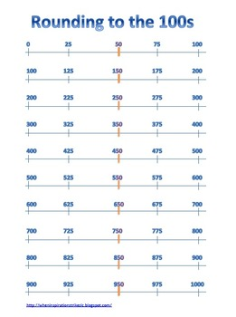
- 229+389=

- 324+218=

- 468+439=

- 674-590=

- 791-612=

- 487-309=

- Put the numbers in order from least to greatest (first compare the hundreds place, then the tens place, then the ones place).

a. 672, 515, 532 b. 787, 683, 564 c.359, 715, 608

______ <_______<_______ _______<_______<_______ _______<_______<_______
d. 959, 915, 908 e. 343, 341, 348 f.165, 746, 764

______ <_______<_______ _______<_______<_______ _______<_______<_______
- Add up the numbers. What is the most common answer?

10+1= 9+2= 8+3= 8+6= 6+5= 8+5= 3+10=
10+4= 9+4= 5+9= 7+6= 7+7= 7+4=
Language Arts projects for 5/4-5/8

- Spelling- band, candy, grand, bend, end, blind, find, kind, Indian, pond, friend, index, second
  - Which words have an: and end ind ond

  - Put the words in alphabetical order.

- Phonics- Write the bold word that finishes the sentence.
  - 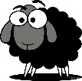a black (sweep, sleep, sheep) f. 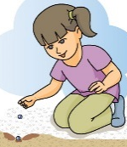planting (bleeds, seeds,
needs)
  - 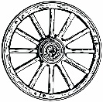a wagon (wheel, feel, peel) g. (peek, cheek, week)
in the box
  - (feet, meet, sweet) buns h. a big (leak, beak, sneak)
  - the best (cream, steam, steam) i. (heal, steal, seal)
on a rock
  - (read, bead, lead) a page j. (heat, seat, beat) the drum

- Handwriting- Write 1 Thessalonians 9:1 as neatly as you can.

- Read at least 3 stories using raz-kids or any other stories if you can't get online. Please make sure your student is only reading stories for their raz-kid account. I do keep track of how much they read.

- English- Journal what you are doing every day. Write at least 3 sentences every day.

- English- Write a cinquin about your mom for Mother’s Day.
Mother

_____________________, ______________________
(two words that describe your mom)

_________________ing, __________________ing, _________________ing
(3 things your mom does)

_________________ _________________ _______________ _________________
(a four word phrase of how you feel about her)

Mom

