Math Projects for 5/4-5/8: We have finished first grade curriculum and this week we are starting an introduction to 2nd grade curriculum. Answer the questions on another piece of paper. Send a picture me by email or text.

= 100 = 10 =1

- Write the number using the pictures.
 | Hundreds | Tens | Ones
 | 0
 | 0
 | 0

- Compare the numbers by writing < (less than), > (greater than), or = (equal to). Look first at the hundreds, then the tens and then the ones places to compare numbers.
a.187 168 c. 165 159 e. 127 141

b. 143 143 d. 157 157 f. 142 158
- Add or subtract the number to the number beside it to fill in the blanks.
  - +2 c. -2 e. -8
10 _____ 10 ______ 10 ______
9 _____ 9 ______ 9 ______
8 _____ 8 ______ 8 ______
7 _____ 7 ______ 7 ______

  - +5 d. -5 f. +6
7 _____ 7 ______ 7 ______
8 _____ 8 ______ 8 ______
9 _____ 9 ______ 9 ______
10 _____ 10 ______ 10 ______
Language Arts projects for 5/4-5/8

- Spelling- her, your, for, mother, girl, or, are, first, Lord, circle
  - Which words have an: er ir or our ar

  - Put the words in alphabetical order.

- Phonics- Write the bold word that finishes the sentence.
  - 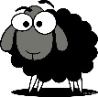a black (sweep, sleep, sheep) f. 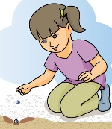planting (bleeds, seeds,
needs)
  - 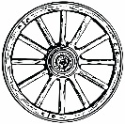a wagon (wheel, feel, peel) g. (peek, cheek, week)
in the box
  - (feet, meet, sweet) buns h. a big (leak, beak, sneak)
  - the best (cream, steam, steam) i. 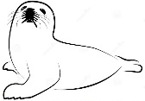 (heal, steal, seal)
on a rock
  - (read, bead, lead) a page j. (heat, seat, beat) the drum

- Handwriting- Write 1 Thessalonians 5:18 as neatly as you can.
- Read at least 3 stories using raz-kids or any other stories if you can't get online. Please make sure your student is only reading stories for their raz-kid account. I do keep track of how much they read.
- English- Write a cinquin about your mom for Mother’s Day.
Mother

_____________________, ______________________
(two words that describe your mom)

_________________ing, __________________ing, _________________ing
(3 things your mom does)

_________________ _________________ _______________ _________________
(a four word phrase of how you feel about her)

Mom

